# Optical Flow and Convolutional Neural Network

# ENPM 673 Project 4

Diane Ngo, 117554960

Problem 1: Optical Flow

Problem 2: Convolutional Neural Network

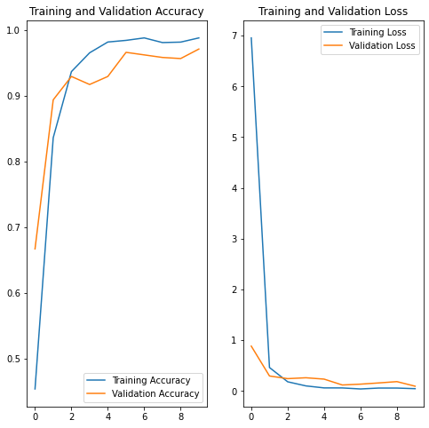

Figure 1. Accuracy vs. Loss, Batch Size 32, 10 layers, and No Rescaling

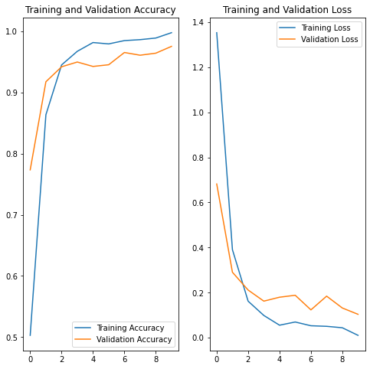

Figure . Accuracy vs. Loss, Batch Size 32, 10 layers, with Rescaling